**DAILY ONLINE ACTIVITIES SUMMARY**

|  |  |  |  |  |  |  |  |
| --- | --- | --- | --- | --- | --- | --- | --- |
| **Date:** | **19/05/2020** | | | | **Name:** | **Tushit Shukla** | |
| **Sem & Sec** | **4 sem & B sec** | | | | **USN:** | **4AL18CS093** | |
| **Online Test Summary** | | | | | | | |
| **Subject** | | **DESIGN AND ANALYSIS OF ALGORITHM IA Test** | | | | | |
| **Max. Marks** | | **30** | | **Score** | | **9** | |
| **Certification Course Summary** | | | | | | | |
| **Course** | 1. [Introduction to Cyber security](https://olympus.greatlearning.in/courses/12628) | | | | | | |
| **Certificate Provider** | | | **Great Learning** | **Duration** | | | **1s hr(spent by me on that day to learn)** |
| **Coding Challenges** | | | | | | | |
| **Problem Statement:**   1. 1. We have a Letter or a word then we need add some letters to it and need to find out shortest palindrome For example we take "S": S will be the shortest palindrome string. If we take "xyz": zyxyz will be the shortest palindrome string So we need to add some characters to the given string or character and find out what will be the shortest palindrome string by using simple java program. 2. Write a simple code to identify given linked list is palindrome or not by using stack. First take a Stack. Traverse through each node of the linked list and push each node value to Stack. Once the traversal & copying is done, iterate through linked list from head node again. In each iteration, pop one stack element and compare with node value in respective iteration. It is expected to match stack popped value with node value. In case of all matches, its a palindrome. Any one element mismatch makes it not a palindrome.   . | | | | | | | |
| **Status: Completed** | | | | | | | |
| **Uploaded the report in Github** | | | | **Yes** | | | |
| **If yes Repository name** | | | | <https://github.com/tushitshukla29/lockdown-program> | | | |
| **Uploaded the report in slack** | | | | **Yes** | | | |

**Online Test Details**

MATHS TEST Details: 18CS45 online test was scheduled from 9:30 am to 10:10 am .The portion for the IA was 1st module, the questions were MCQ type.

**Online Certification Details**: Career and Industry Landscape

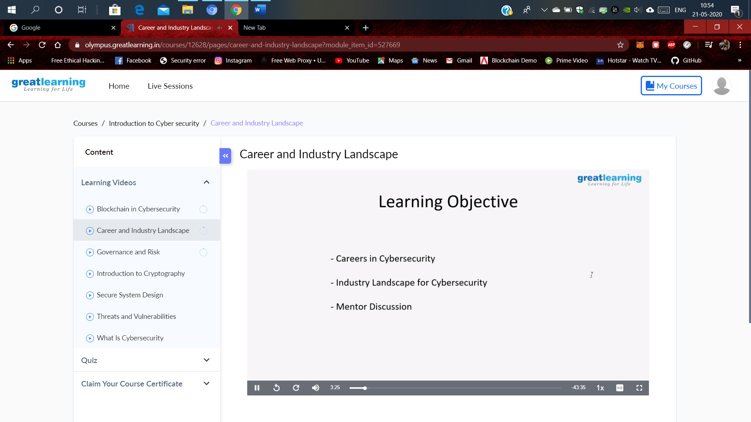

**Coding Challenge Detail :** I have written programs and uploaded it to my Github repository.

Link as follows: 1. <https://github.com/tushitshukla29/lockdown-program/blob/master/19052020%20pg1>

1. <https://github.com/tushitshukla29/lockdown-program/blob/master/19052020%20pg2>